Keys to maximizing the drive phase.
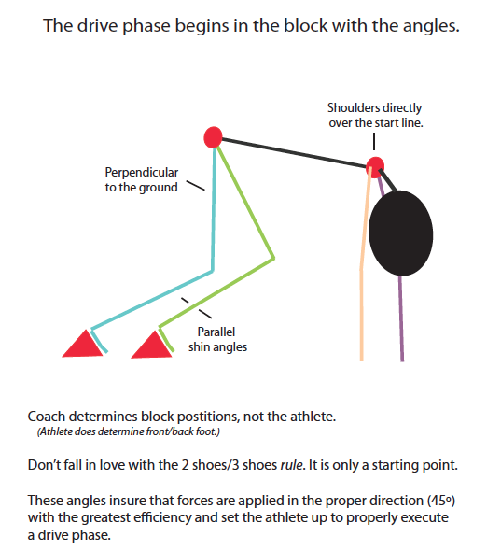
Jay Miles, Aloha HS
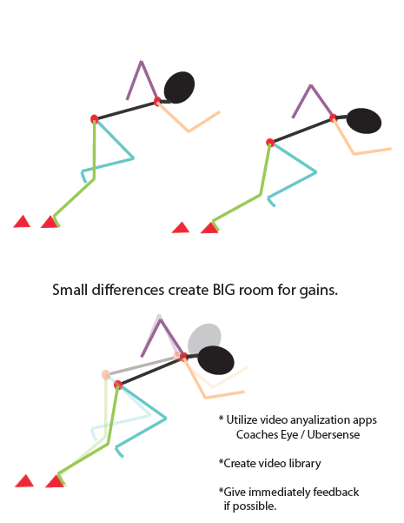
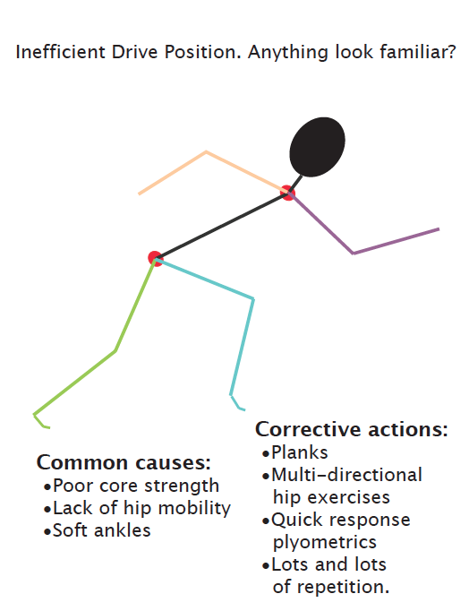
- Drive phase is a violent occurrence.
  - Greater forces are needed to overcome resting inertia.

- Form over distance.
  - A shorter drive phase executed correctly is more valuable than o longer one done in poor position.
  - The goal for an efficient HS sprinter is about 25m drive phase. But only when the proper form is in place.

- Greater ground contact times
  - Each step is a long push to full extension.

Notes:

